1.
#include<iostream>
using namespace std;
int main(){

cout<<"Hello World!"<<endl;
return 0;
}

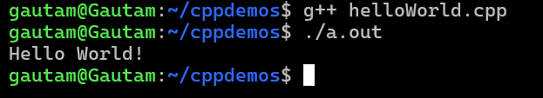
2.
#include<iostream>
using namespace std;

int main(){

int num1, num2;
cout<<"Enter 2 Numbers: "<<endl;
cin>>num1>>num2;

cout<<"Addition :"<<num1<<" + "<<num2<<" = "<<num1+num2<<endl;

return 0;}
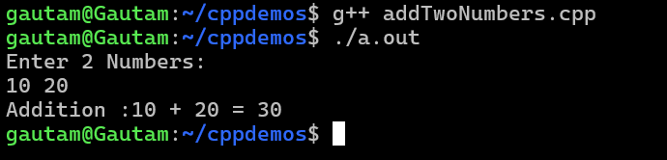
3.#include<iostream>
using namespace std;

int binarySum(int x, int y){
while(y != 0){
int carry = x & y;
x = x^y;
y = carry<<1;

}
return x;
}

int main(){

int x, y;
cout<<"Enter 2 Numbers: "<<endl;
cin>>x>>y;

cout<<"Binary Sum is: "<<binarySum(x, y)<<endl;
return 0;
}
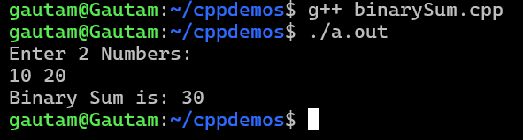

4.
#include<iostream>
using namespace std;

int main(){
char ch1, ch2;
cout<<"Enter 2 Characters: "<<endl;
cin>>ch1>>ch2;
int sum = ch1+ch2;

cout<<"Addition :"<<ch1<<" + "<<ch2<<" = "<<sum<<endl;

return 0;
}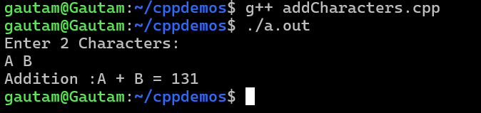

5.
#include<iostream>
#include<cmath>
using namespace std;

int main(){

int pr, n;
double r;

cout<<"Enter Principal, Rate(in points) and Years"<<endl;
cin>>pr>>r>>n;

int CI = pr * (pow((1 + r), n)-1);

cout<<"Compound Interest is: "<<CI<<endl;
}

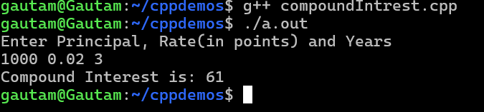

6.
#include<iostream>
using namespace std;

int main(){
int b,n;

int p = 1;

cout<<"Enter Base and Exponent: "<<endl;
cin>>b>>n;

for(int i = 0;i<n;i++){
p = p*b;
}
cout<<"Power of "<<b<<" raise to "<<n<<" is "<<p;

}

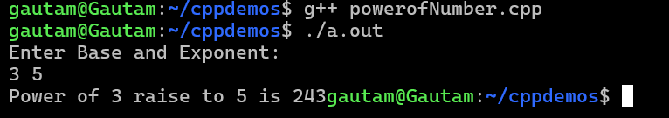

7.

#include<iostream>
using namespace std;

void swapNumbers(int *a, int *b){

int temp = *a;
*a = *b;
*b = temp;
}
int main(){

int a, b;

cout<<"Enter two Numbers: "<<endl;
cin>>a>>b;

cout<<"Before Swaping"<<a<<" ,"<<b<<endl;

swapNumbers(&a, &b);
cout<<"After Swaping"<<a<<" ,"<<b<<endl;

return 0;
}

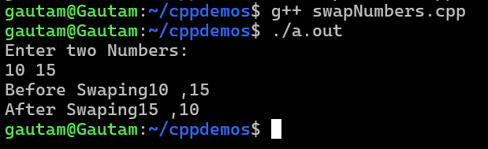

8.#include<iostream>
using namespace std;

int area(int l, int w){

int area = l*w;

return area;

}
int main(){

int l, w;

cout<<"Enter lenght and width: "<<endl;
cin>>l>>w;

cout<<"Area of Rectangle is: "<<area(l, w);

return 0;
}
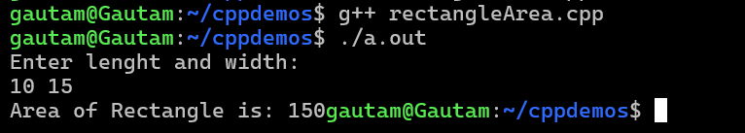

9.
#include<iostream>
using namespace std;

int digitSum(int n){
int sum = 0;

while(n != 0){
int lastDigit = n%10;
sum += lastDigit;
n = n/10;
}
return sum;}

int main(){

int n;
cout<<"Enter a 4 digit Number: "<<endl;
cin>>n;

cout<<"Digit Sum of"<<n<<" is "<<digitSum(n)<<endl;

return 0;
}

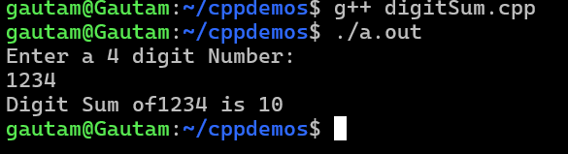

10.
#include<iostream>
using namespace std;

int digitSum(int n){
int sum = 0;
if(n == 0)
return 0;

return (n%10) + digitSum(n/10);
}

int main(){

int n;
cout<<"Enter a 4 digit Number: "<<endl;
cin>>n;

cout<<"Digit Sum of"<<n<<" is "<<digitSum(n)<<endl;
return 0;
}


11.
#include<iostream>
using namespace std;

int fibonacci(int n){
if(n == 1)
return 0;
else if(n == 2)
return 1;
return fibonacci(n-1)+fibonacci(n-2);
}
int main(){
int n;

cout<<"Enter Number: "<<endl;
cin>>n;

for(int i = 1; i<=n ;i++){
cout<<fibonacci(i)<<endl;
}
return 0;
}
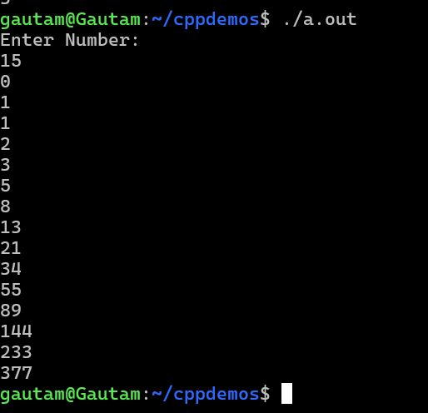
12.
#include<iostream>
using namespace std;

void decToBin(int n){

if(n == 0)
return;

decToBin(n/2);
cout<<n%2;
}

int main(){

int n;
cout<<"Enter Number: "<<endl;
cin>>n;

decToBin(n);
return 0;
}